[To change the hostname of the machine (permanently)]

The exact details are in this article:
https://www.cyberciti.biz/faq/ubuntu-18-04-lts-change-hostname-permanently/

I basically did:
sudo hostnamectl set-hostname <newname>

and then:
sudo nano /etc/hosts and replaced any occurrences of the old hostname with the new name and saved the file (ctrl+x) and press Y and exit.

And then finally a reboot:
sudo reboot.

Done.

I din’t follow the nixcraft approach mentioned in the article.

The hostnamectl command basically outputs the hostname of the machine, machine id, os, kernerl and the cpu architecture.

I also tried doing some research regarding changing the username as well, but it is a long and tedious process and good changes of things going wrong, so din;t mess with it.

[To time the shutdown of the machine]

You can use the shutdown command. It basically allows you to halt/shutdown/reboot a linux machine.

Just shutdown will power-off the machine in 1 minute.
And, shutdown now will do an immeidate shutdown.
And, shutdown +5 will do it in 5mins from now.
You can also do a reboot with a -r option: shutdown -r +5 will reboot in 5 mins from now.

In fact, there is a plain reboot comman also, with which also you can do all 3 things, and if you do not give any args, it will by default reboot.

[To monitor network traffic]

iftop can be used to monitor network traffic.

To install: sudo apt install iftop
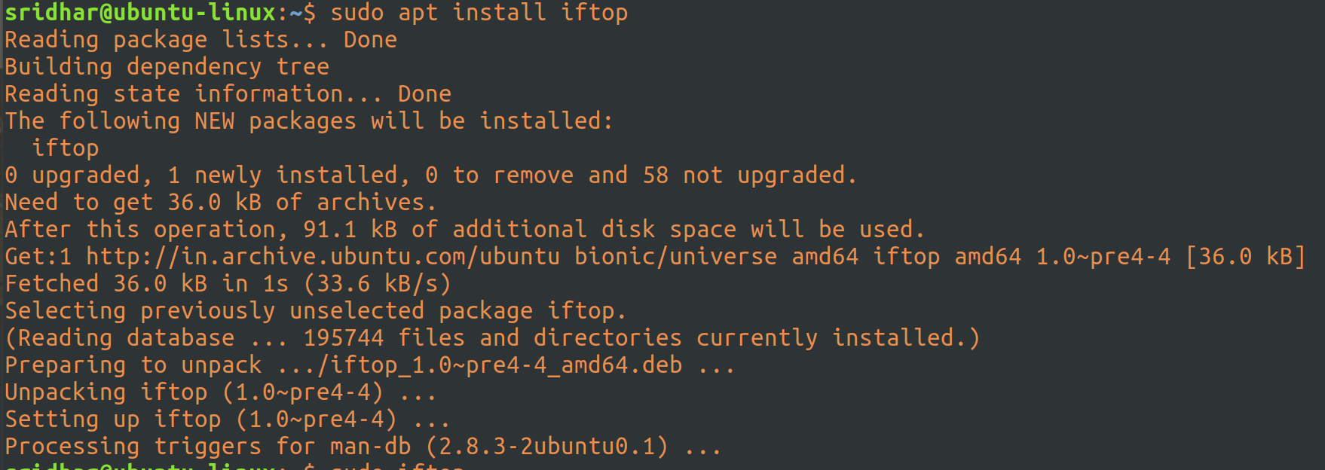
iftop needs to be run with root priveleages, if you run it otherwise, it will fail to capture traffic:

Now, let’s run iftop with sudo: sudo iftop

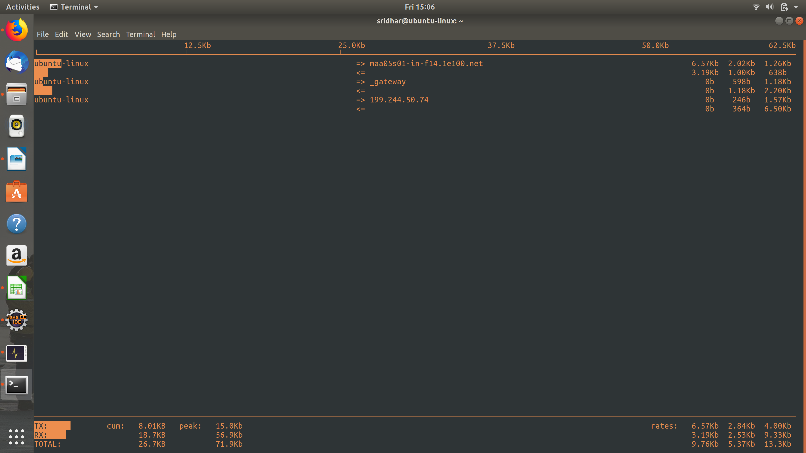
As you can see, it starts capturing traffic.

To also look at port display, meaning, to switch on port display, just press ‘p’ on the keyboard while the iftop is running:

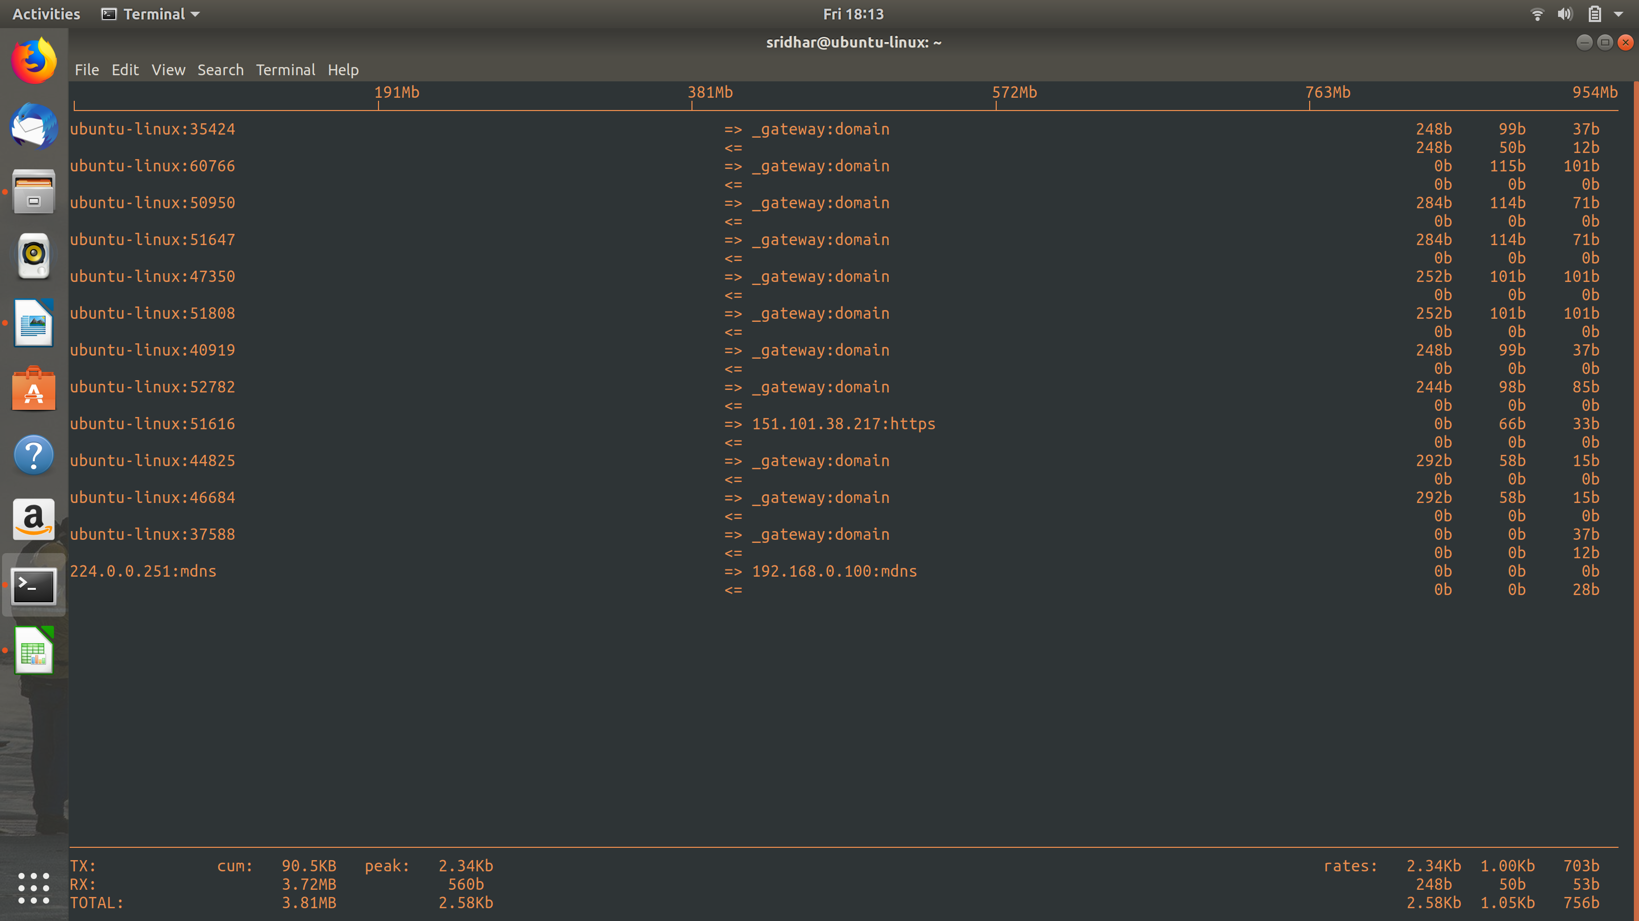

[To display and monitor linux processes]

In order to see which processes in your machine are taking a lot of cpu/memory, you can use the ‘top’ command.

To run, just issue the command: top

and you’ll the list of processes running currently in your machine, by default, sorted by cpu consumption:

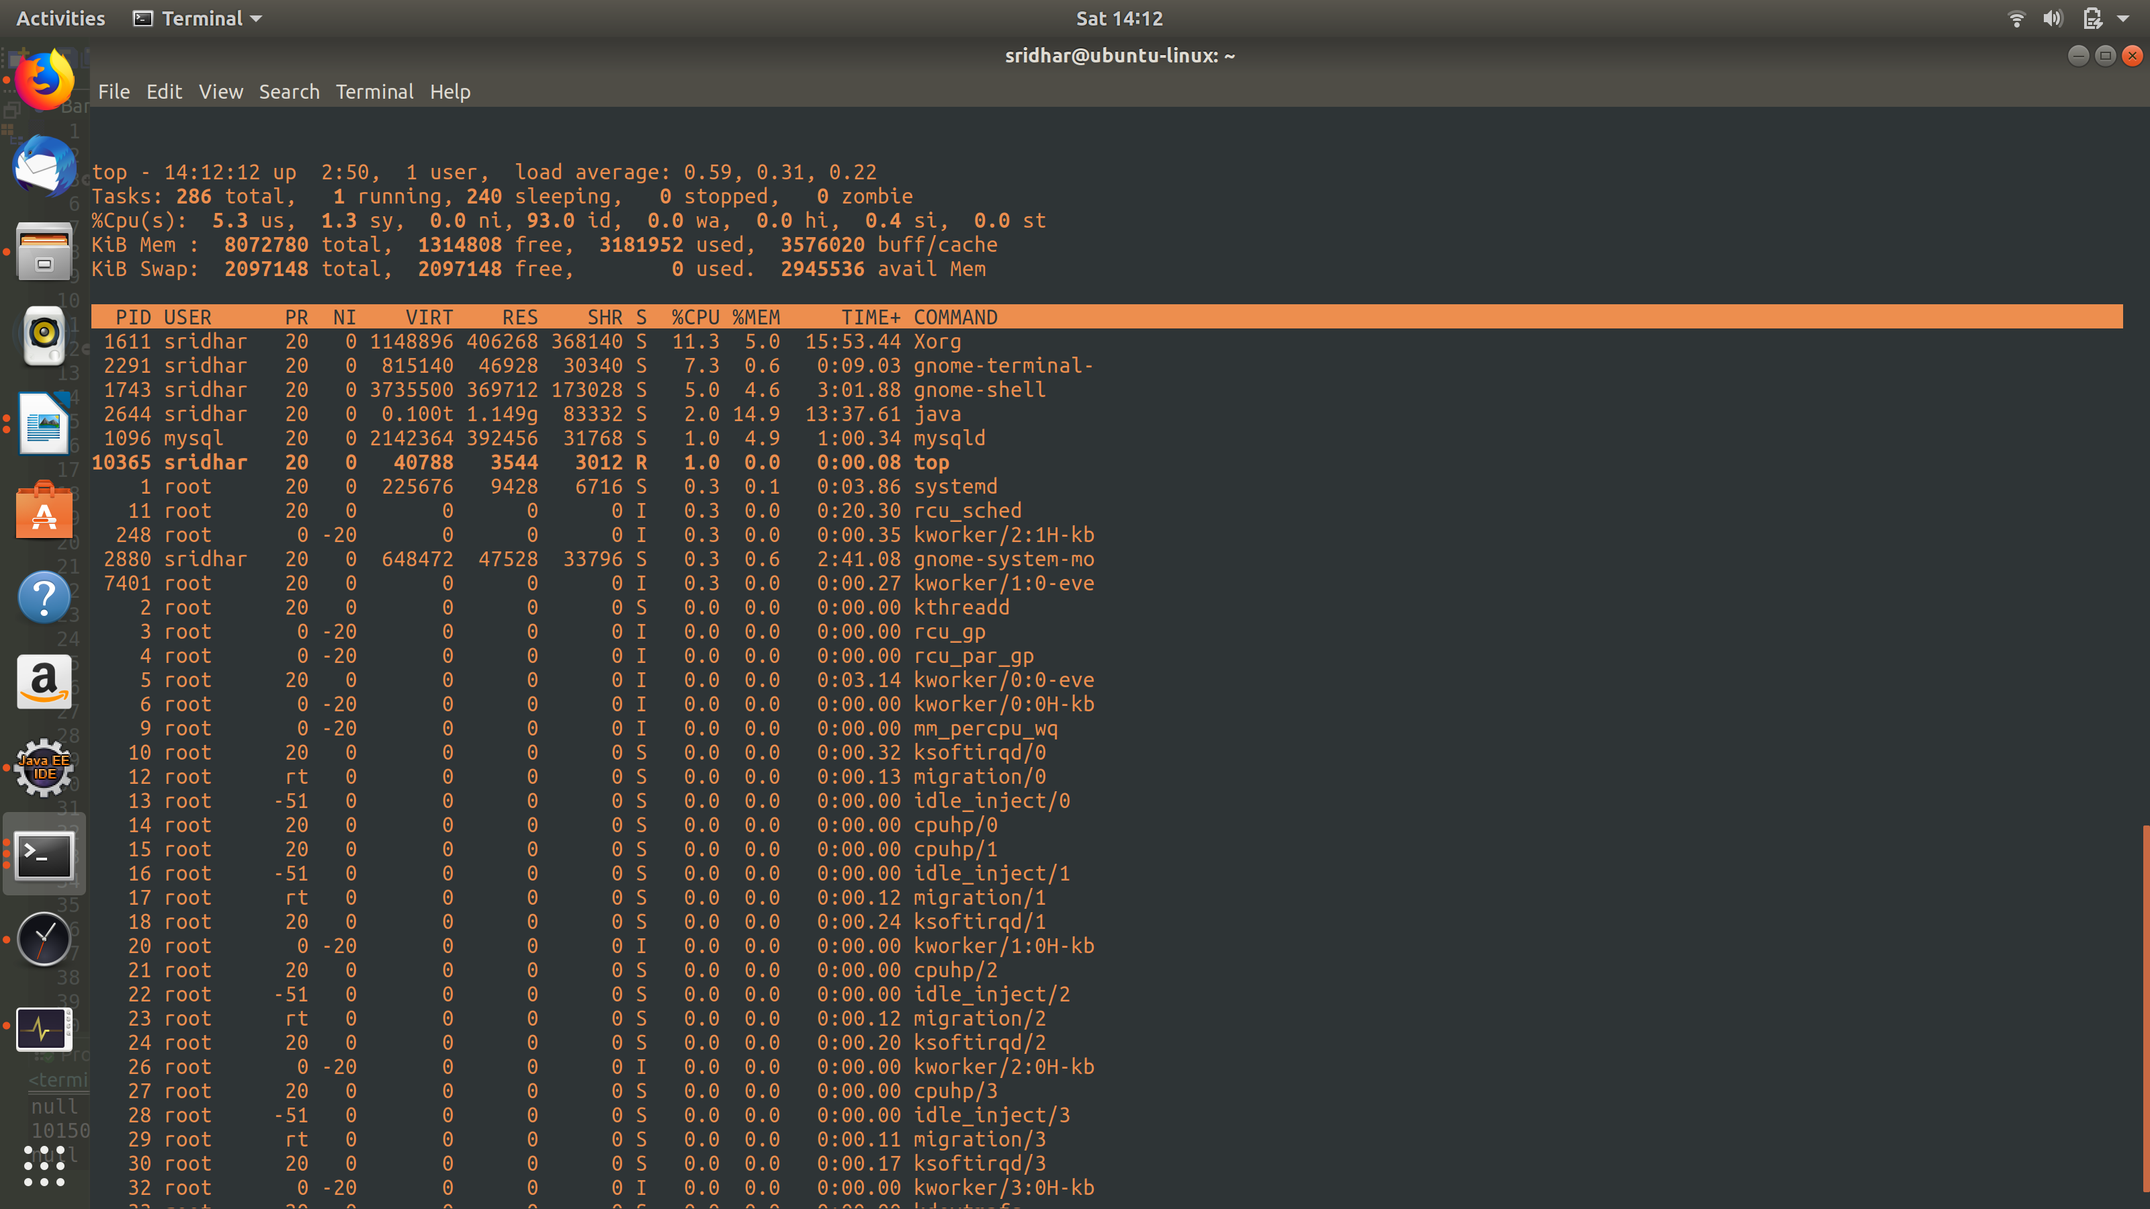

If you want to sort it by any other paramter, then simply press
‘shit + f’ while the top is running:

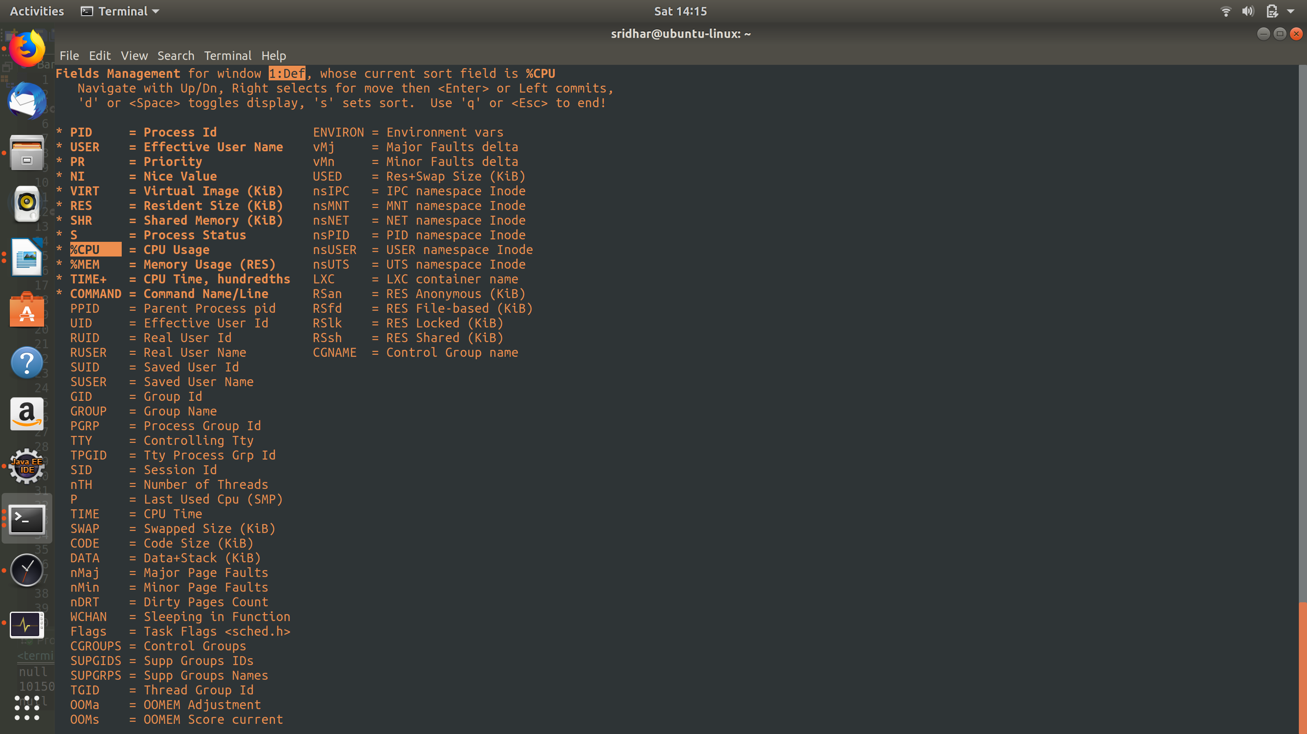
And, you’ll get to see a list of options on the basis of which you can sort.

Use arrow keys to select the sort and then press ‘s’ and press ‘q’:
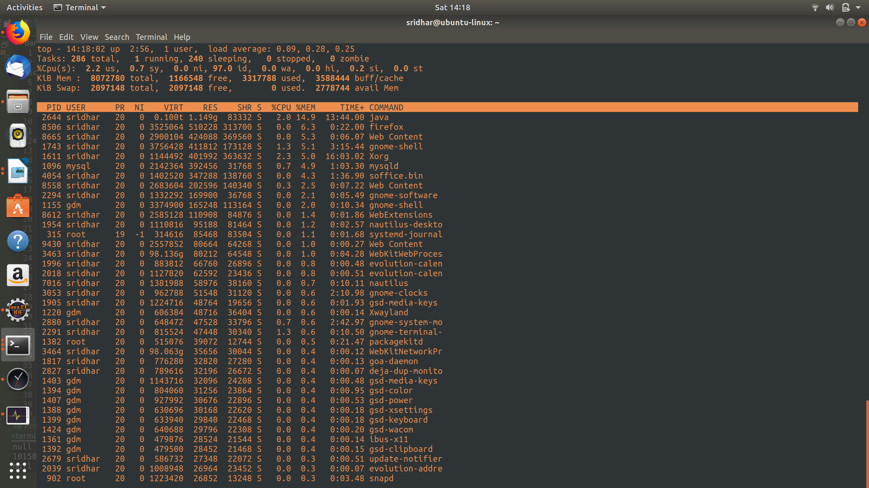

And, as you can see from above, it is now sorted on the basis of memory consumption.

